The two use cases use the same database(since they have a lot of similarities and both in a same app)

1. ER Diagr

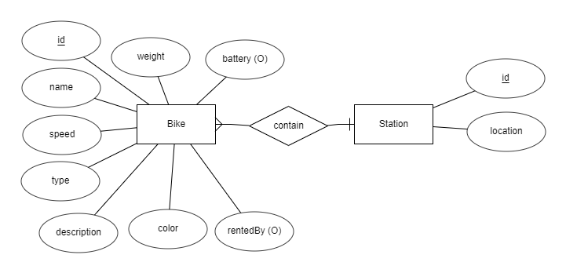

1. Logical Data Model

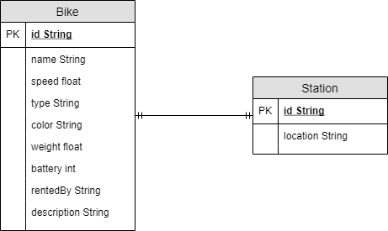

1. Physical Data Model ( NoSQL-MongoDB)

use database

1. Station

|  |  |  |  |  |  |  |
| --- | --- | --- | --- | --- | --- | --- |
| # | PK | FK | Name | Data Type | Mandatory | Description |
| 1 | V |  | Id | String | Yes | // |
| 2 |  |  | location | String | Yes | // |
| 3 |  | v | bikeId | String[] | no | Id of the bikes in the station. A station maybe empty |

db.createCollection(bike)

1. DeliveryInfo

|  |  |  |  |  |  |  |
| --- | --- | --- | --- | --- | --- | --- |
| # | PK | FK | Name | Data Type | Mandatory | Description |
| 1 | V |  | Id | String | Yes | // |
| 2 |  |  | name | String | yes | // |
| 3 |  |  | speed | float | Yes | Max speed |
| 4 |  |  | type | String | Yes | Bike,ebike,… |
| 5 |  |  | color | String[] | Yes |  |
| 6 |  |  | weight | float | Yes |  |
| 7 |  |  | battery | int | no | Only Ebike has |
| 8 |  | v | rentedBy | String |  | = Null when at station.  = userId when rented |
| 9 |  |  | description | String | no |  |

db.createCollection(station)